**Applied Cognitive Computing**

**Push Notifications – IBM Bluemix + Android**

1. Download and install git (if you haven’t already):

<https://git-scm.com/downloads>

1. While you download git, go to the Bluemix Catalog (<https://console.ng.bluemix.net/catalog/>)
2. Click on MobileFirst Services Starter.

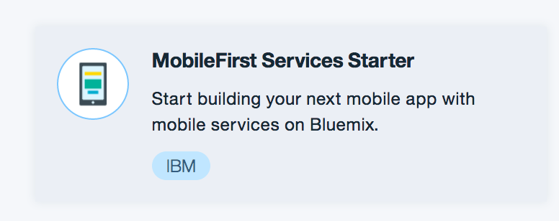

1. Provide a name for you app. When you do, the host name should be auto populated. Do not change anything else. Click on Create.

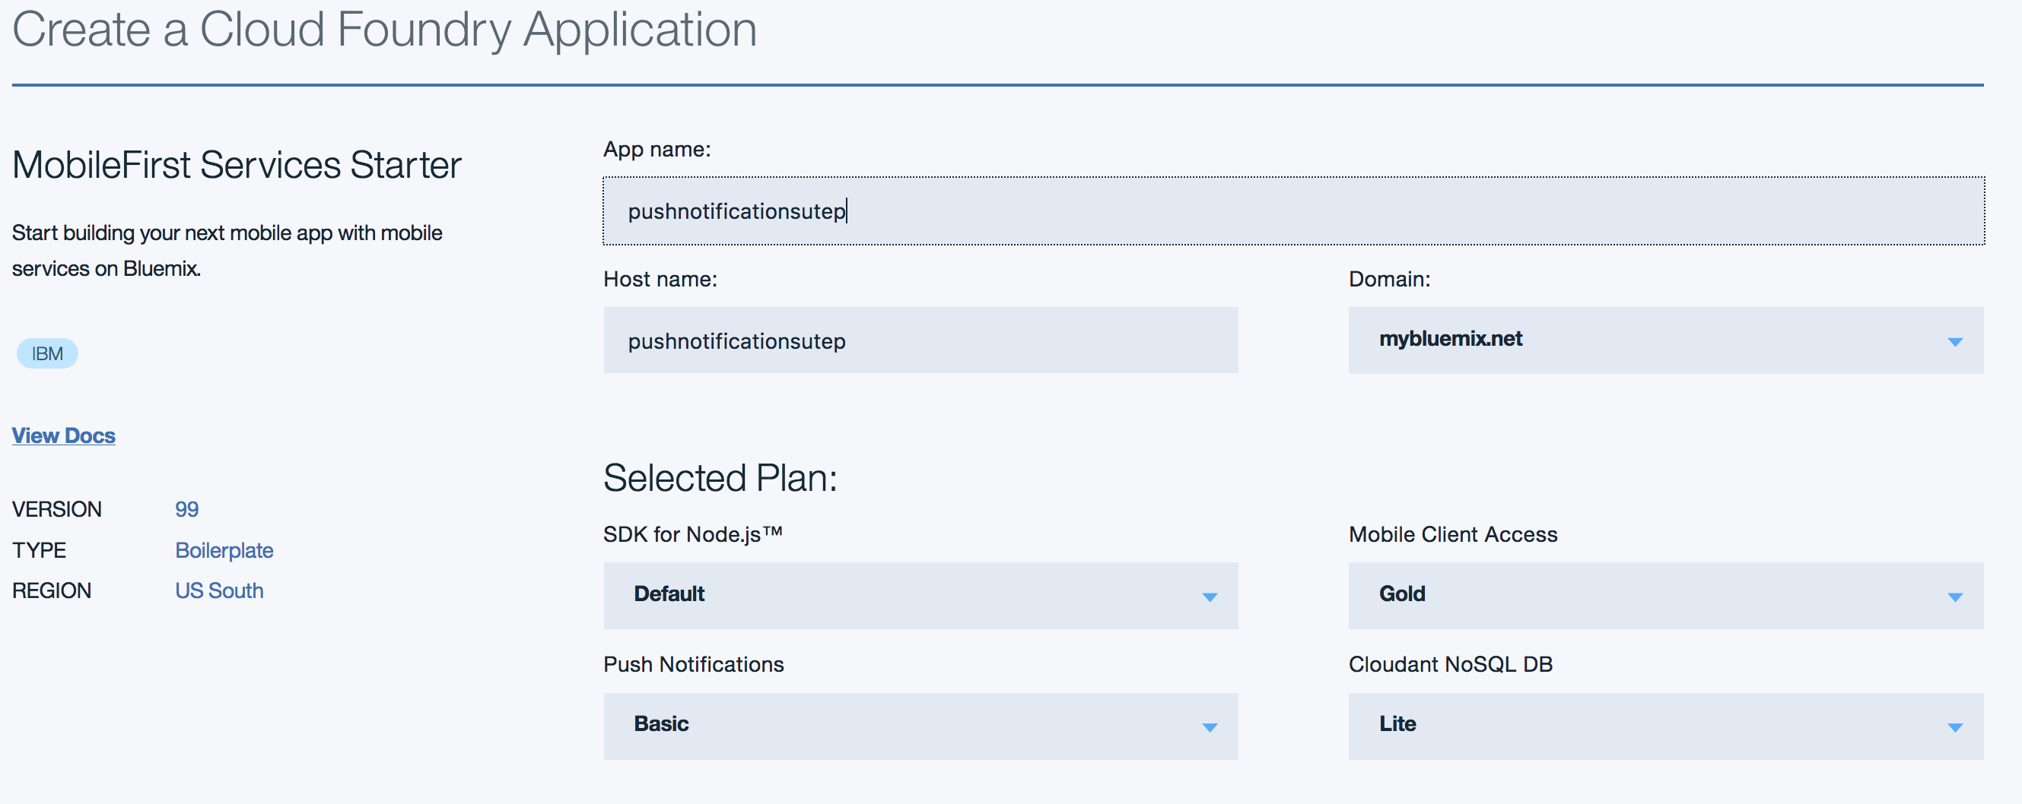

1. Once your project is created, you’ll see the following:

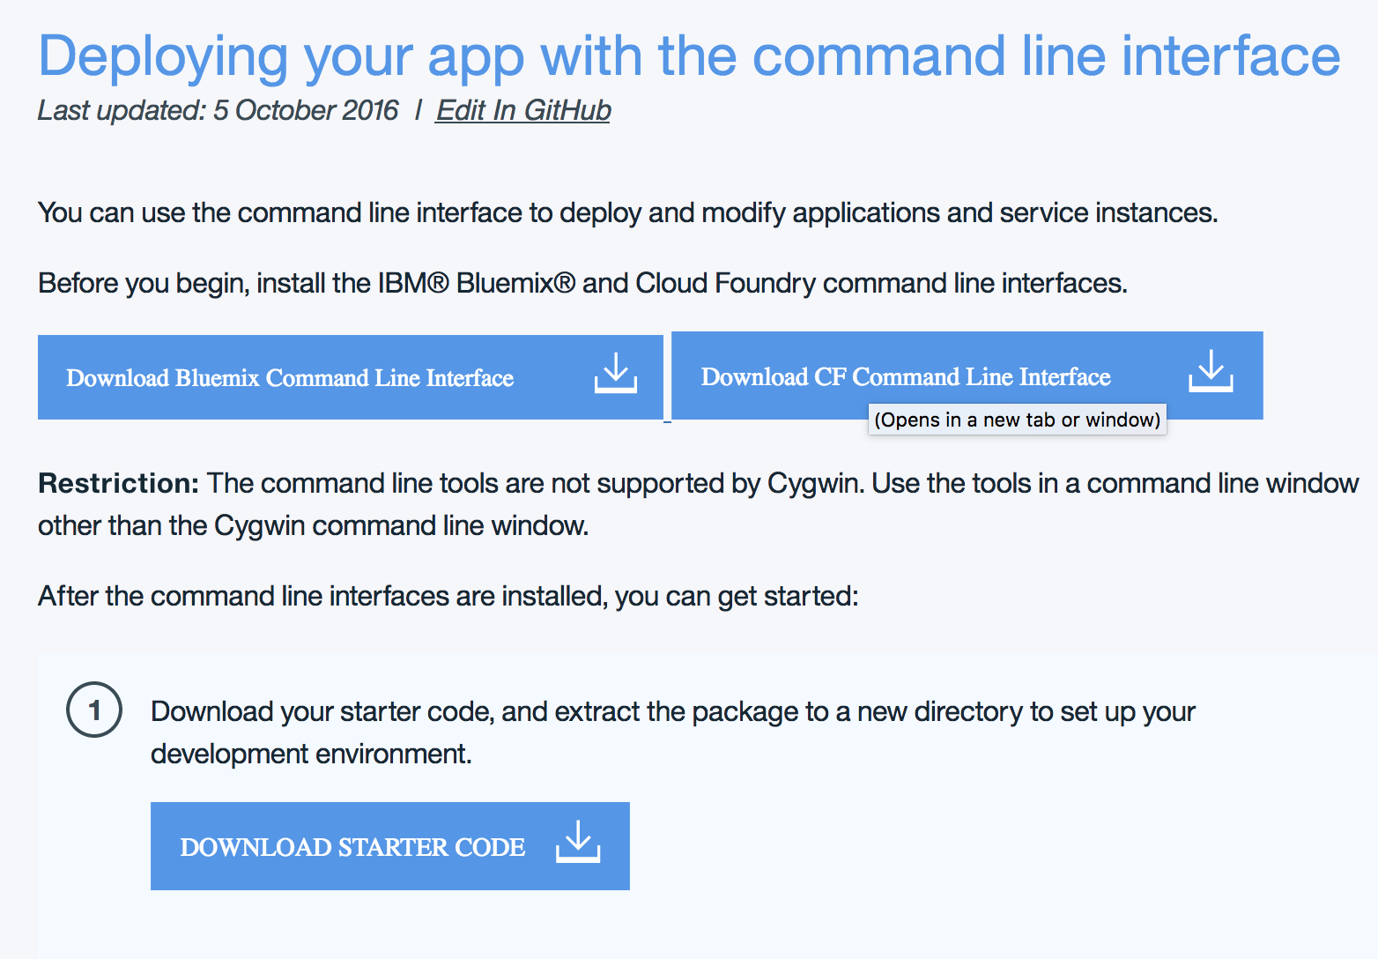

1. Bluemix asks you to install the IBM Bluemix and Cloud Foundry command interfaces. We’ll do this later on.
2. Click on Download Started Code
3. Unzip the file. We’ll modify the contents of the resulting folder later on.
4. Open the Command Prompt (Windows) / Terminal (macOS/Linux) and change your current directory (cd) to the directory you want to use for this tutorial.
5. Install git if you haven’t already and run the following git command.

git clone https://github.com/ibm-bluemix-mobile-services/bms-samples-android-hellopush

1. The project you just cloned is an Android application (helloPush). Open it using Android Studio:

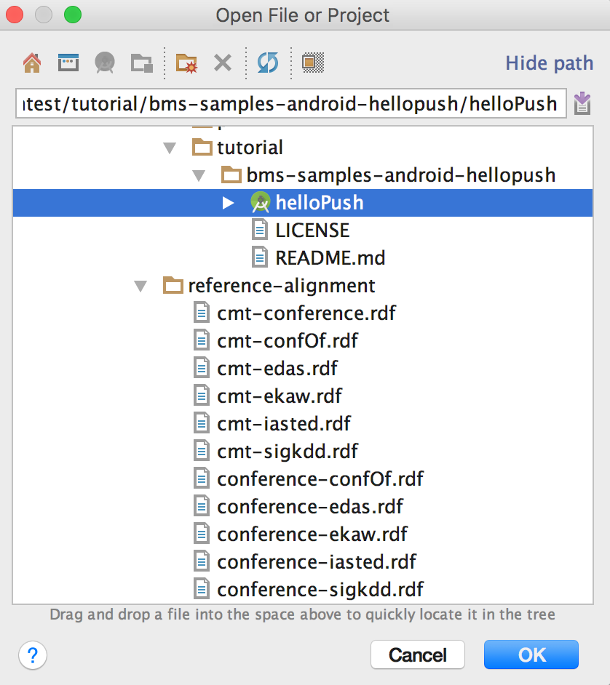

1. Open MainActivity.java
2. Find this line:

push.initialize(this, "<APP_GUID>", "<CLIENT_SECRET>");

1. We need to populate <APP_GUID> and <CLIENT_SECRET>. To do this, go back to your Bluemix Dashboard: <https://console.ng.bluemix.net/dashboard/applications>

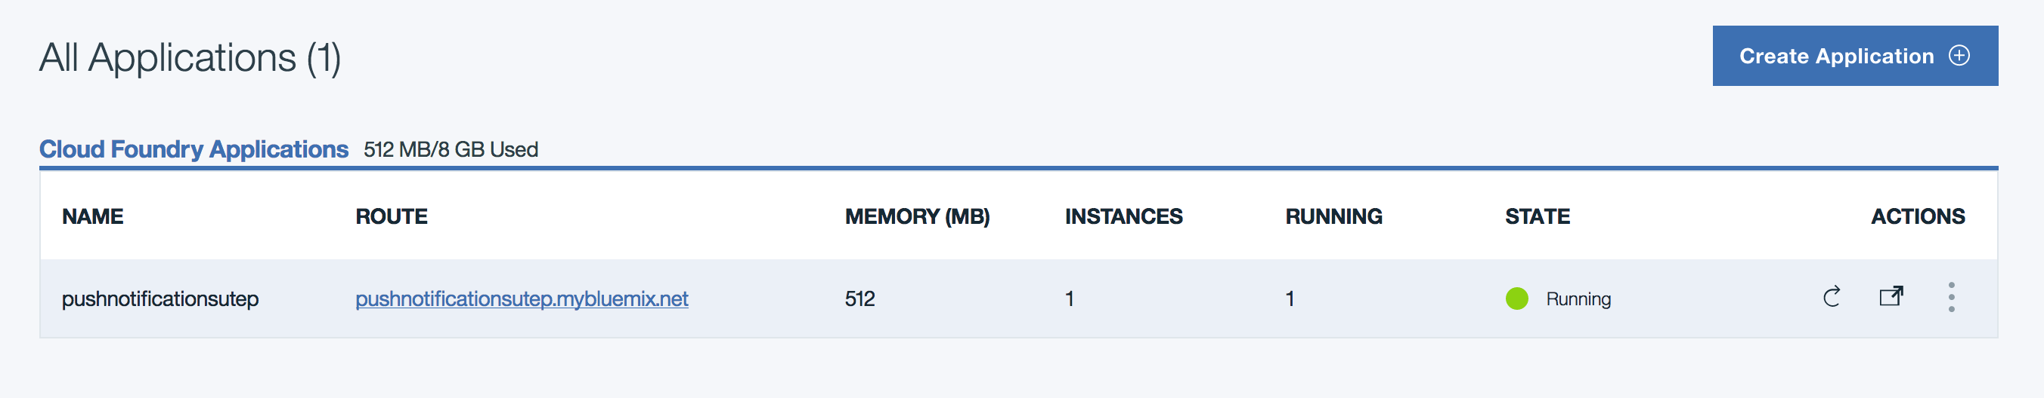

1. Click on the name of your project
2. Identify the Connections web part, and click on the connection that ends with -imfpush

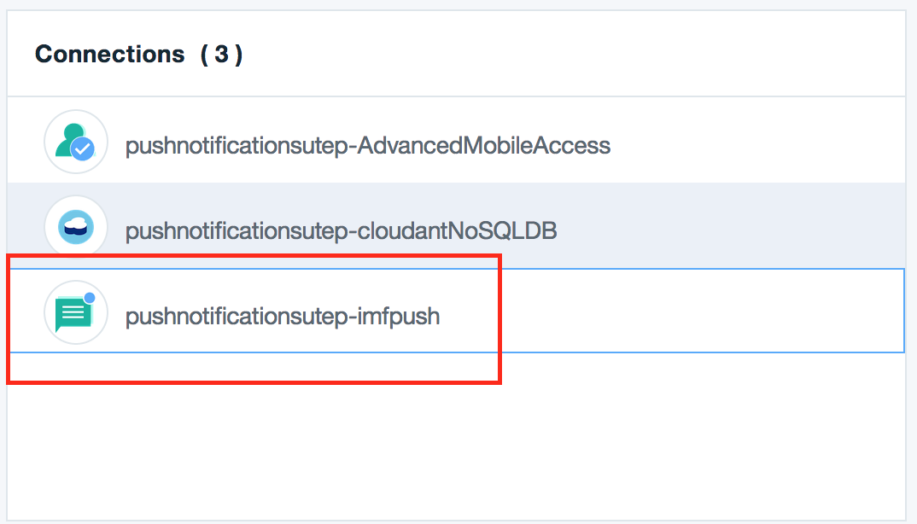

1. Click on Configure now
2. Click on Mobile Options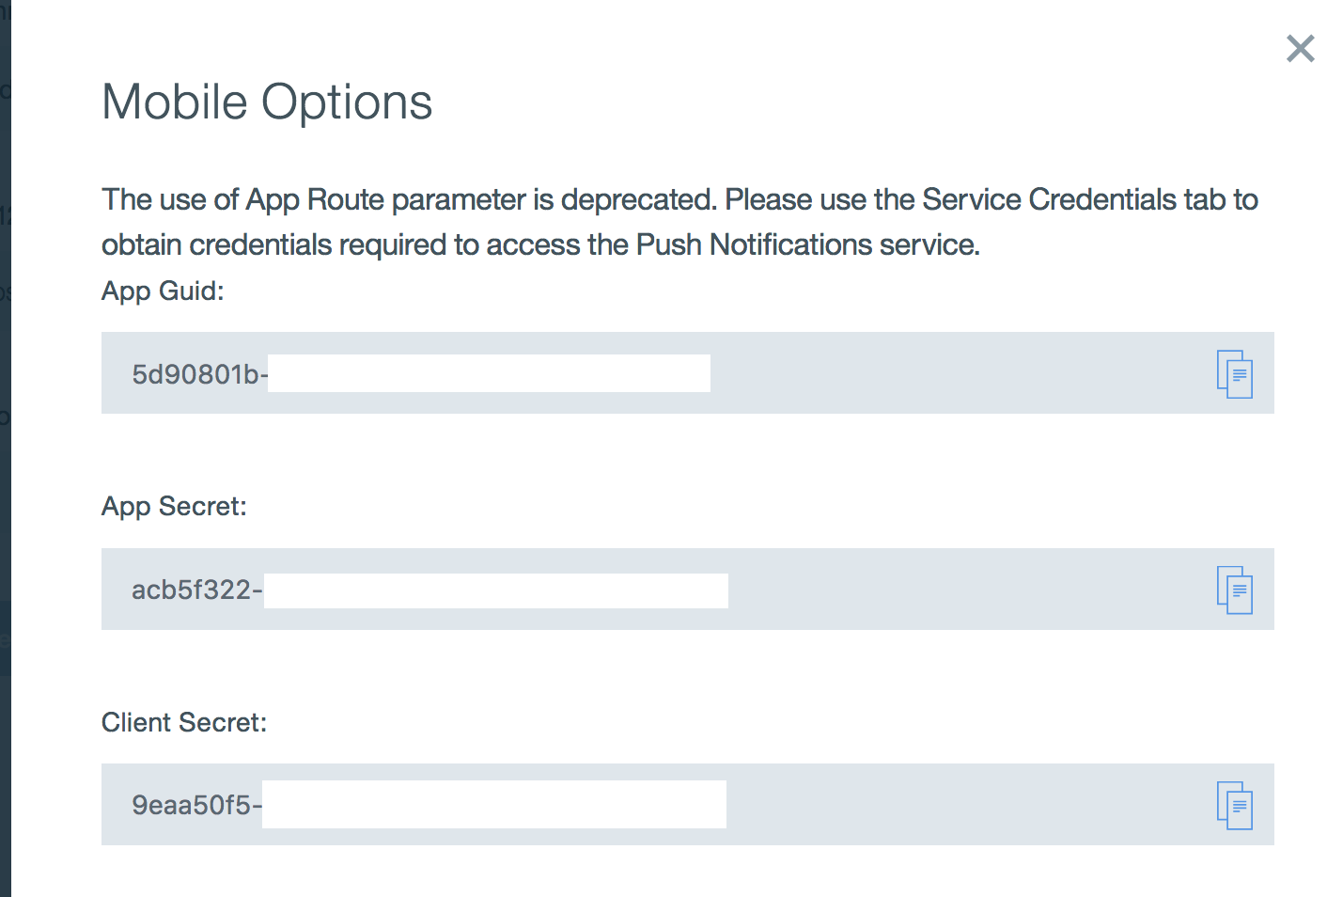
3. In your MainActivity.java, replace <APP_GUID> with the App Guid, and replace <CLIENT_SECRET> with the Client Secret

Macintosh HD:Users:diegoaguirre:Desktop:Screen Shot 2016-11-08 at 10.10.20 AM.png

1. Leave the page open; we’ll go back to it in a minute. For now, we need to configure our Firebase Cloud Messaging (FCM) to be able to receive/send push notifications. Go to the FCM page: <https://console.firebase.google.com/>
2. Log in with a Google account
3. You’ll see the following:

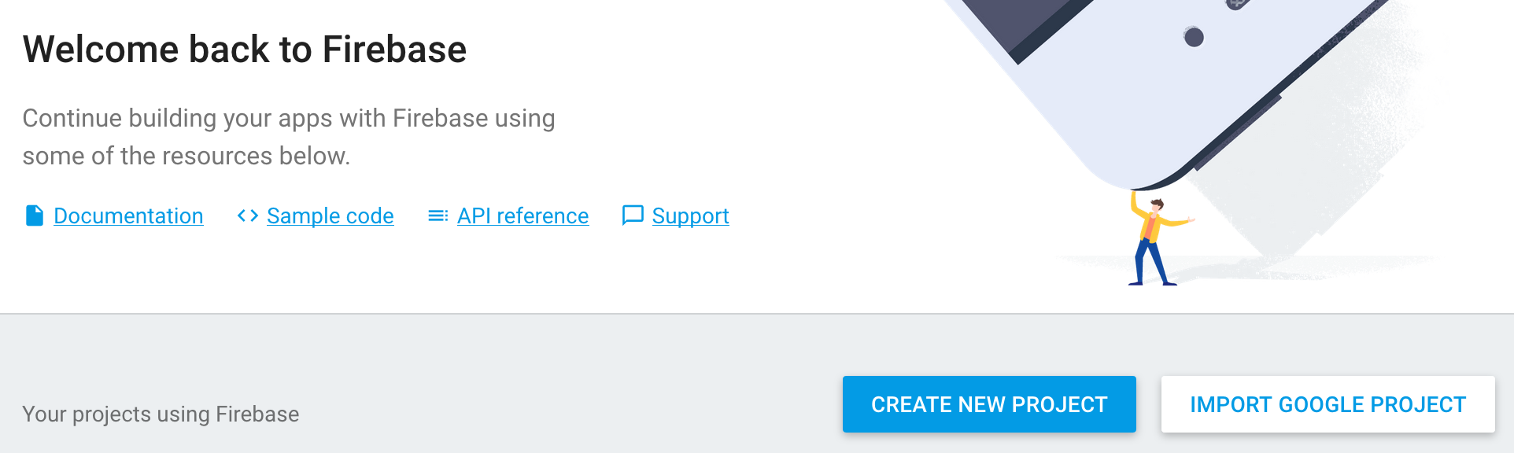

1. Click on Create New Project. Give your project the same name you have to your Bluemix app, and then click on Create Project.
2. Once your FCM project has been created, click on the Settings gear, and then Project Settings:

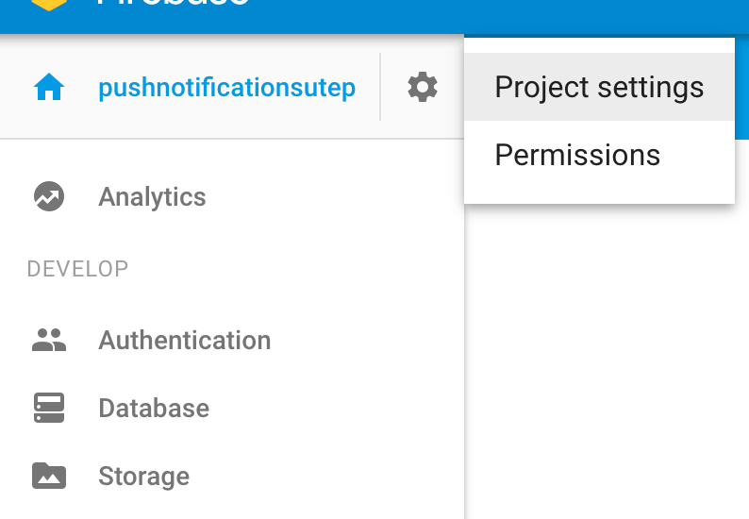

1. Click on Cloud Messaging

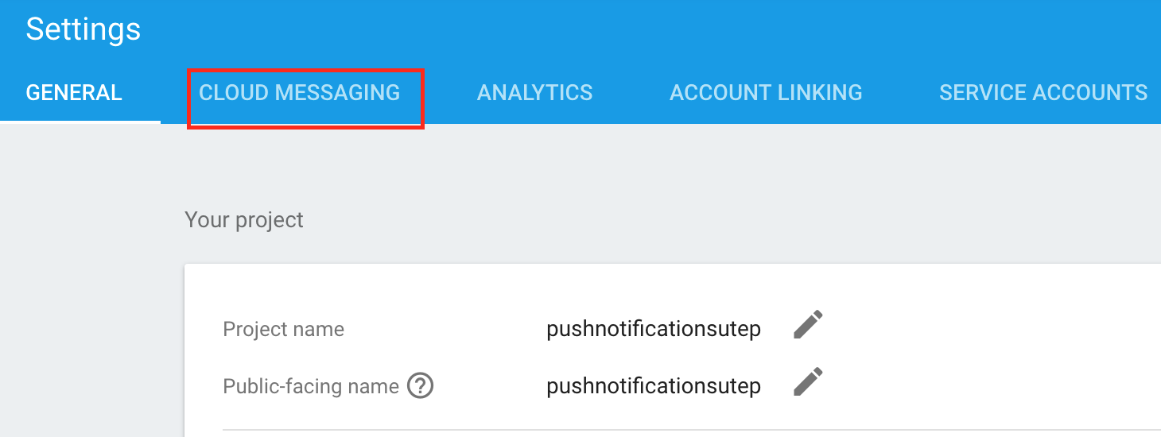

1. You’ll see the following:

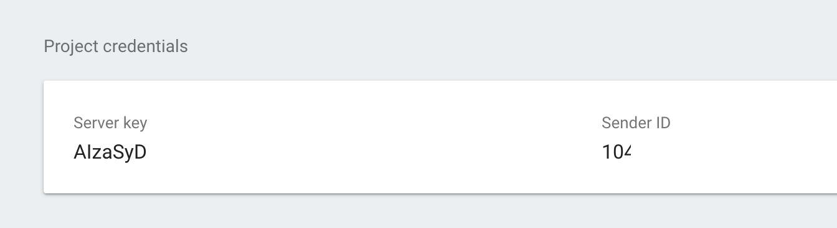

1. Go back to the Bluemix page where you obtained the APP_GUID and the CLIENT_SECRET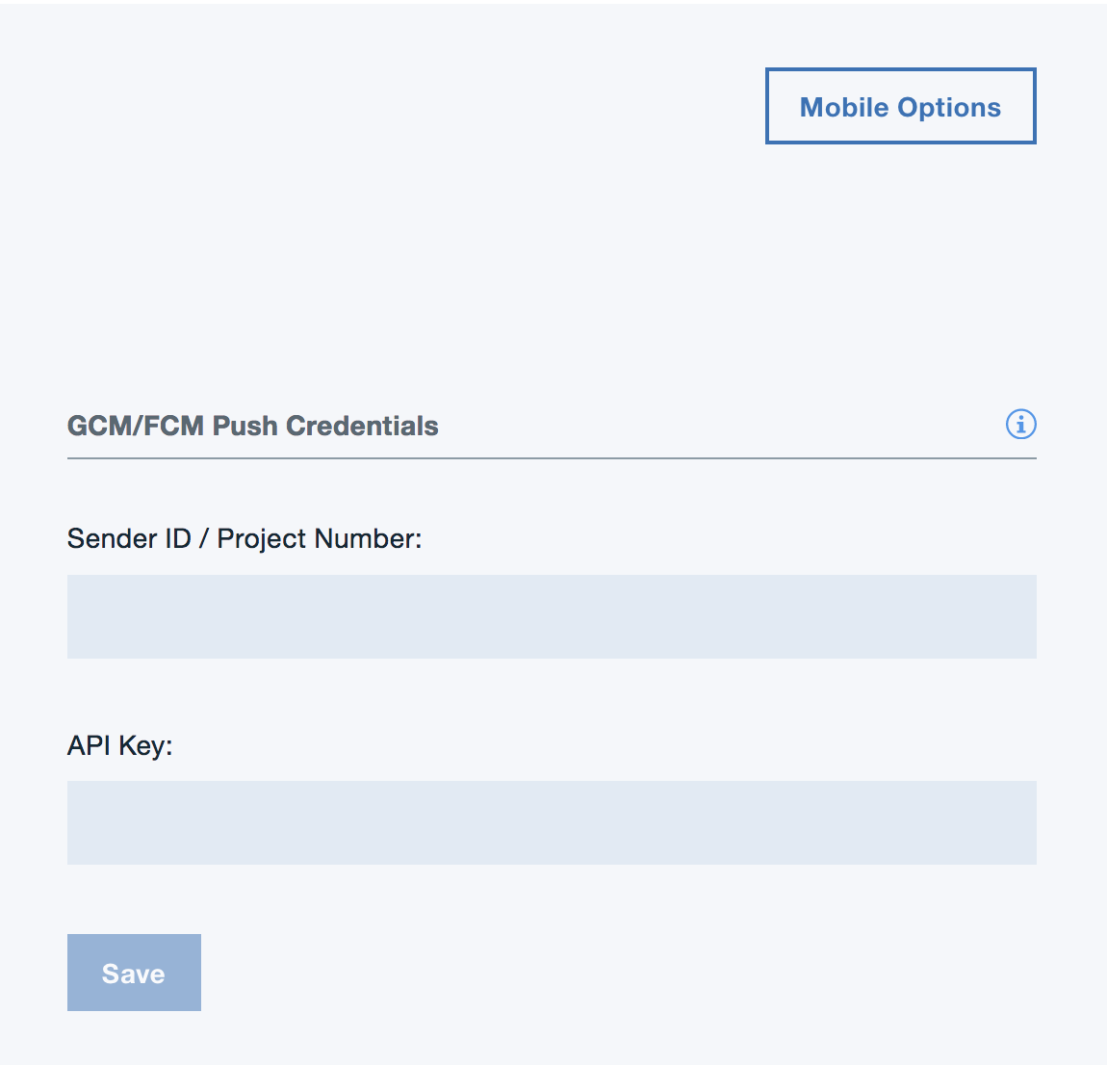
2. Populate Sender ID/Project Number using the Sender ID you are seeing in the Firebase Page: Similarly, populate API key with the Server key from Firebase. Click on Save
3. Run the Android App.
4. When the application loads, click on Register device
5. Once the device is registered to receive Push Notifications, go back to Bluemix, and click on Send Notifications

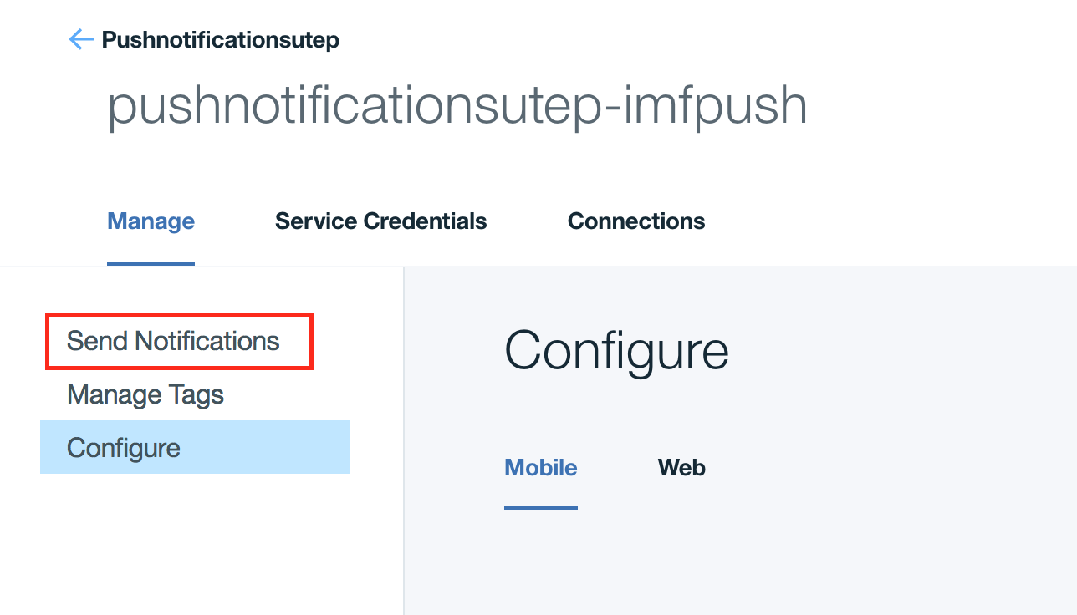

1. Type a message and click send. You should receive a push notification on your Android device / emulator.

**Send a push notification programmatically**

1. Download and install these libraries:

[http://clis.ng.bluemix.net/ui/home.html](%22)

[https://github.com/cloudfoundry/cli/releases](%22)

1. In step 7 from the previous tutorial, you downloaded and uncompressed a zip file. Delete it, ignore it, bury it… We don’t need it
2. Download the following zip file: <https://dl.dropboxusercontent.com/u/42085525/server.zip>
3. Unzip the file, and open *manifest.yml*
4. Replace the name and the host fields with your own
5. Open server->app->routes->pushnotifications->SendPushNotification.js
6. Update the following line using your app’s information: PushNotifications(PushNotifications.Region.US_SOUTH, "your-bluemix-app-guid", "your-push-service-appSecret");
7. You can find this information on the Bluemix page where you configure the Push Notifications Service



1. In your terminal/ command prompt, cd to the server folder and run the following commands:

cf api https://api.ng.bluemix.net

cf login

cf apps

cf push -f manifest.yml

1. Visit the following page from a browser (or do a GET Request from any device/ programming language): https://<YOUR_APP>.mybluemix.net/sendPushNotification

When you do so, the code in server -> app -> routes -> pushnotifications -> SendPushNotification.js will be executed. The code is simple; you should be able to understand it (or at least partially understand it) even if you have not worked with JavaScript before.

The code sends a notification to all the devices that are registered to your service (the ones that are ‘listening’). If you run your Android application on multiple devices, and they all register to your app’s push notification service (by pressing the button), they all will get a notification when the code in SendPushNotification.js executes.

If you want to send a notification to a subset of the registered devices, read the documentation here: <https://github.com/ibm-bluemix-mobile-services/bms-pushnotifications-serversdk-nodejs>